Lab Journal Fourier Analysis

Saban Caliskan

2023-04-29

**What I did**

I have to admit that I haven’t been able to do much, because of king’s day.

However, I did make a github so I can upload and update this lab journal and my code.

I also started writing a simple code that creates a data set of a sinusoidal function and also plots the FFT of and the original function using the inverse FFT, like gerhard asked me to. I used some internet for this: <https://pythonnumericalmethods.berkeley.edu/notebooks/chapter24.04-FFT-in-Python.html>.

At first I couldn’t get the IFFT graph to work, but soon found that the problem was me; I immediately put the FFT values in abs().

**Comments:**

* I noticed that the FFT graph is symmetric around the middle point: i.e If I spot a maximum at the first position, another maximum with the same amplitude will be at the last position. I expected it to be symmetric around the x=0 axis.
* I noticed that the timestep between two points of the sinusoidal dataset is equal to total Interval / ( amount of data points in between).

And the frequency step between two data points in the FFT graph is equal to 1 over this.

2023-05-01

Meeting with Gerhard

Had my first meeting With Gerhard Blab, he gave me some code he wrote in MATLAB and explained to me what he expected of me.

He’s expecting me to write a python version of his code and improve it.

He’s also expecting me to find out when which type of fit works best under which circumstances and if the amount of data points impact the fit (they do).

Gerhard was also kind enough to give me access to the Ornstein Lab and to a computer in the building as my main laptop is broken right now.

We also agreed on meeting once every monday.

2023-05-07

Finally managed to find some time to start ‘translating’ Gerhard’s code from MATLAB into Python.

I had a lot of issues figuring out how the FFT_peakFit function worked, but managed to figure it out. The barycentric and quadric methods were easy to implement, sadly the other two kept giving me figures that didn’t match Gerhard’s.

Sadly, due to the being busy with elections and the department’s day of physics I haven’t been able to do much more, so I decided to mail Gerhard to postpone our meeting till friday after the elections and Department’s day

2023-05-11

Finally managed to make the plot comparing code parts work. Figured out what I did wrong with the other two methods. The method’s described on <https://dspguru.com/dsp/howtos/how-to-interpolate-fft-peak/> that Gerhard sent me work better than those I previously found on google with the same name.

Also Made a start with the second half about noise analysis, but ran into a problem where Gerhard tries to add an array of 1000 by 700 to a list of 699 elements in line 92. I’ll ask him on friday about what he was trying.

I also did some literature research and tried to find out about how to quantify if a peakfit is relatively good or bad. <https://www.researchgate.net/publication/284178826_Good_Practices_for_XPS_and_other_Types_of_Peak_Fitting_Use_Chi_Squared_Use_the_Abbe_Criterion_Show_the_Sum_of_Fit_Components_Show_the_Normalized_Residuals_Choose_an_Appropriate_Background_Estimate_Fit>

2023-05-15

Had another meeting with Gerhard. I showed the new code, which I changed a bit to make it a bit more one to one with his MATLAB code. I also made a few changes.

We noticed that the compareplot part of the code, although it worked, was taking in the wrong data, because I sliced it incorrectly.

He also mentioned that I got a bit confused with the word Fit, we’re not actually fitting the data. So the literature research (mentioned above) was in vain. With Peak fit, we mean that we made a code that just analyzes the data and finds the peaks in the DFFT data we get from our original dataset. We also shouldn’t confuse FFT with the DFFT, the discrete works differently and has therefore other caveats.   
He’s expecting me to write a code that can perform a general set of tasks. The code should both be able to compare the plots for different shifts in phase and for background noises, it should also be able to plot for different methods of peak fits.

We also noticed that the Jains and Quinn's 2nd method both were the most reliable, even though they’re not continuous and the other two are.

2023-05-16

Worked on the code and tried to implement what gerhard mentioned, but the graph’s i got were complete nonsense. Luckily, I had a meeting with Gerhard for something completely different, so I asked him what I did wrong. I completely misunderstood what data he meant during our meeting last monday.

We also set some deadlines for next monday. I’m going to work a bit on the code and make a presentation that I can show him, so he can judge what I will present for Wednesday next week.

2023-05-20

Mostly just worked on the presentation, but I did change the code a bit to create graphs for the presentation. Also made a way to analyze phase differences with a single for loop.

I also made a flow chart but it really wasn’t making anything clearer as the python code was really 2 different python codes because of the if statement, so we decided to leave it out.  
  
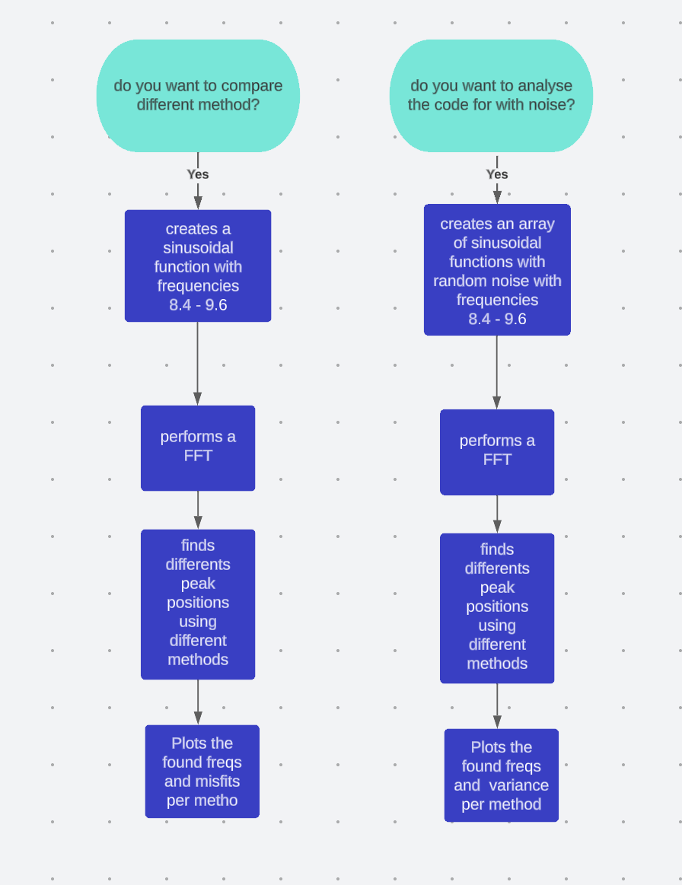

2023-05-22

Got feedback from Gerhard on my presentation, he found it not professional enough and it had some mistakes. I also had some slides he wanted merged or removed. I’m going to improve my presentation before tomorrow.

He also pointed out that I did something wrong with the Quins2nd method, as it gave a different result, my find peaks were a bit more off and not as straight as his.

2023-05-23

I Sent my improved version to Gerhard, he again had some suggestions that I changed and we cleared up some misunderstandings. I overdid it by reducing the amount of text on the slides.

I'm going to change these before tomorrow.

I couldn’t find out what i did wrong with the Quinns 2nd method

2023-05-24

Today I had the presentation.

2023-05-27

I spent the entire day trying to find out what I did wrong with the Quinn’s 2 method, all the input data and original function seemed to be correct. I also compared it with multiple methods I found online and it all matched. I also tried to implement Quinn’s 1st method, but that one was way more off. I couldn’t find the mistake, so I decided to focus on separating the simulation of data from the result by comparing part of the code, to make it more broad.  
  
 2023-05-29

There was no meeting with Gerhard because of pentecost

2023-06-02

Gerhard Gave me some improvements through the mail and instructions, i implemented these, such as name change. I decided to make a new document instead, so I could still refer back to the original code.   
I also added a gaussian noise, and repeated the fit 1000 times for 1000 frequencies.

To create the gaussian noise i both multiply and add a gaussian distribution to the input data, to make it ‘fiddle out’ and give it the amplitude at the beginning.

In general the value of the actual peak position (with noise) is more correct around integers, in between integers the standard deviation does become bigger and thus more uncertain.

Still the Quinns and Jains method do seem to perform better than gaussian and barycentric methods even with gaussian noise, altho less so than without gaussian noise.

2023-06-05

I had a meeting with Gerhard today, he told me to clean up my code as it uses a lot of if statements. He suggested using the def() function and adding more comments. He also told me to focus on noise without the Gaussian envelope to it.

2023-06-9

I changed everything the if statements in the code in the desired way with def() functions, but couldn't find enough time to fully change it because of U-Council.

2023-06-10

I finished changing the code into with def() functions.

2023-06-12

I had another meeting with gerhard, we made plans to finish up this research as it’s coming to an end in 2 weeks.

2023-06-12

.He found 2 different methods. He sent a snippet of Macleod to me, but did tell me to wrap up and focus on the current 4 methods and start writing a start to the final report. I immediately started writing an abstract and introduction that night.

2023-06-14

I added a Theory part.

2023-06-19

I showed gerhard my progress with the report, he told me to send it to him as soon as possible so he could peer review it. I told him i’d finish it this evening.

Sadly i couldn’t finish it that evening, I overestimated how much work it was and got busy with other stuff. I mailed gerhard i’d finish it by wednesday evening. Such that incase he doesn’t have time I could always send it to Marijn.

2023-06-21

I finished the entire report and send it Gerhard.

2023-06-22

Gerhard gave me a lot of comments and improvements. I immediately started and did most

2023-06-24

I finished all the comments and tips Gerhard gave me.

2023-06-25

I proofread it again and cleaned up my github.